**CST8921 – Cloud Industry Trends**

**Lab 3 – Cosmos db change feed**

# Introduction

In this lab, I will explore and understand the faculties of CosmosDB by creating a CosmosDB database, implementing the database’s containers and using .NET tools such as cosmicworks to seed the database with sample data. The goal is then to create an Azure function that monitors and responds to changes to the database, such as seeding it. The CosmosDB I am generating is a NoSQL serverless database. NoSQL databases are Important databases that can store semi-structured data allowing efficient querying.

## Objective

The goal of this lab activity is to navigate Cosmos DB and observe database changes.

# Screen Shots

**Process change feed events using the Azure Cosmos DB for NoSQL SDK**

1. Cloning the github repository of cosmos-db-dev  
   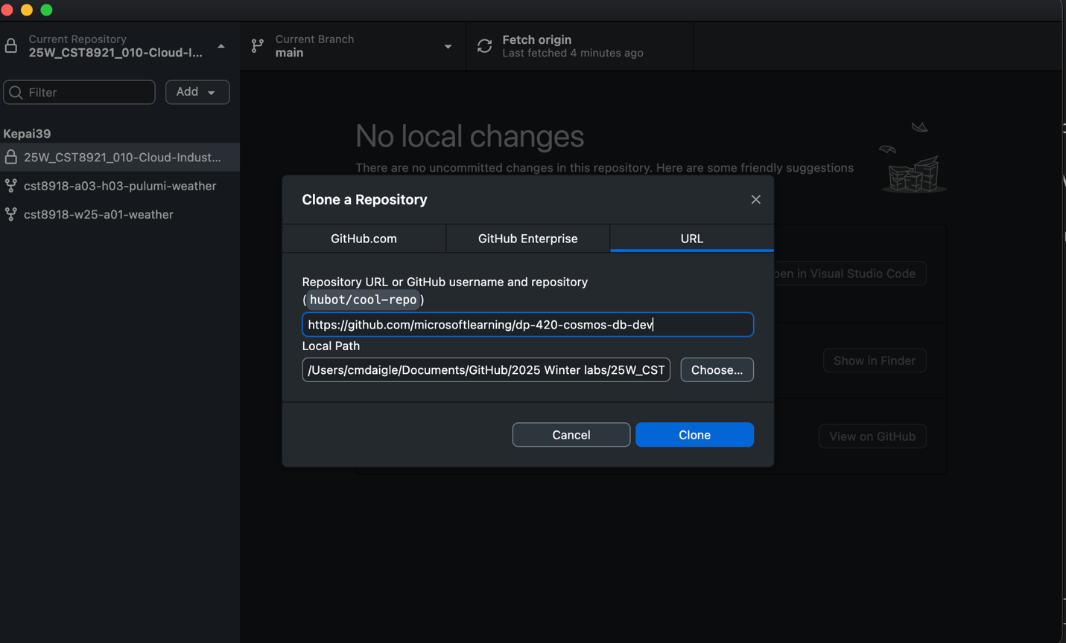
2. Creating a azure cosmos db for nosql account. Choose capacity mode as serverless.

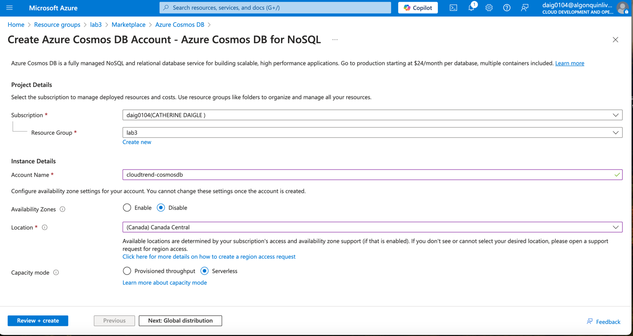

1. Azure Cosmosdb database creation review:

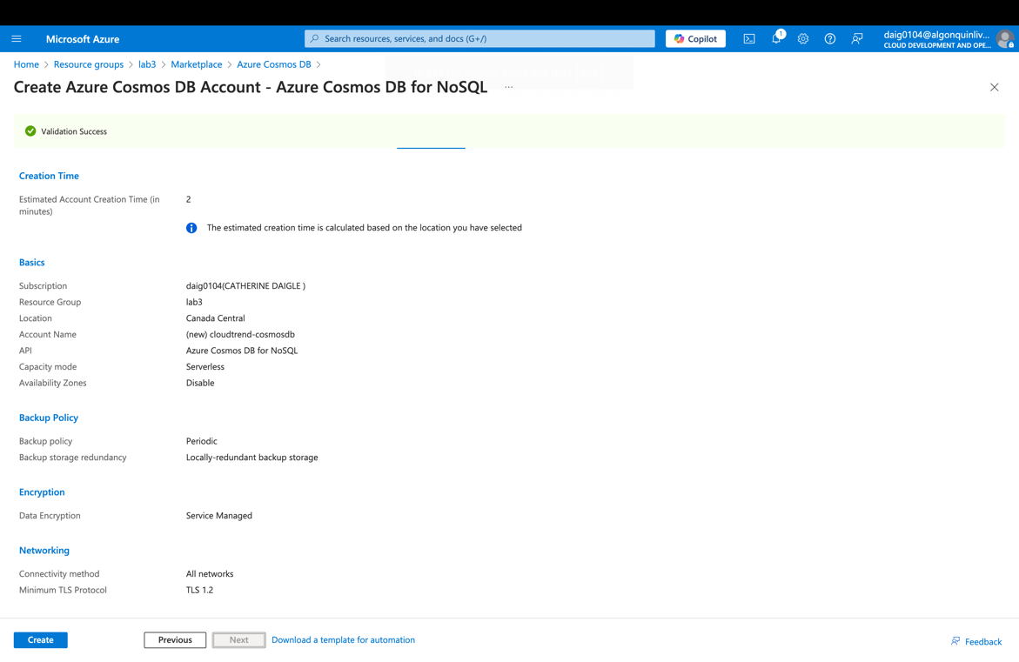

1. Connection credentials, endpoint & primary key for cosmosdb database:

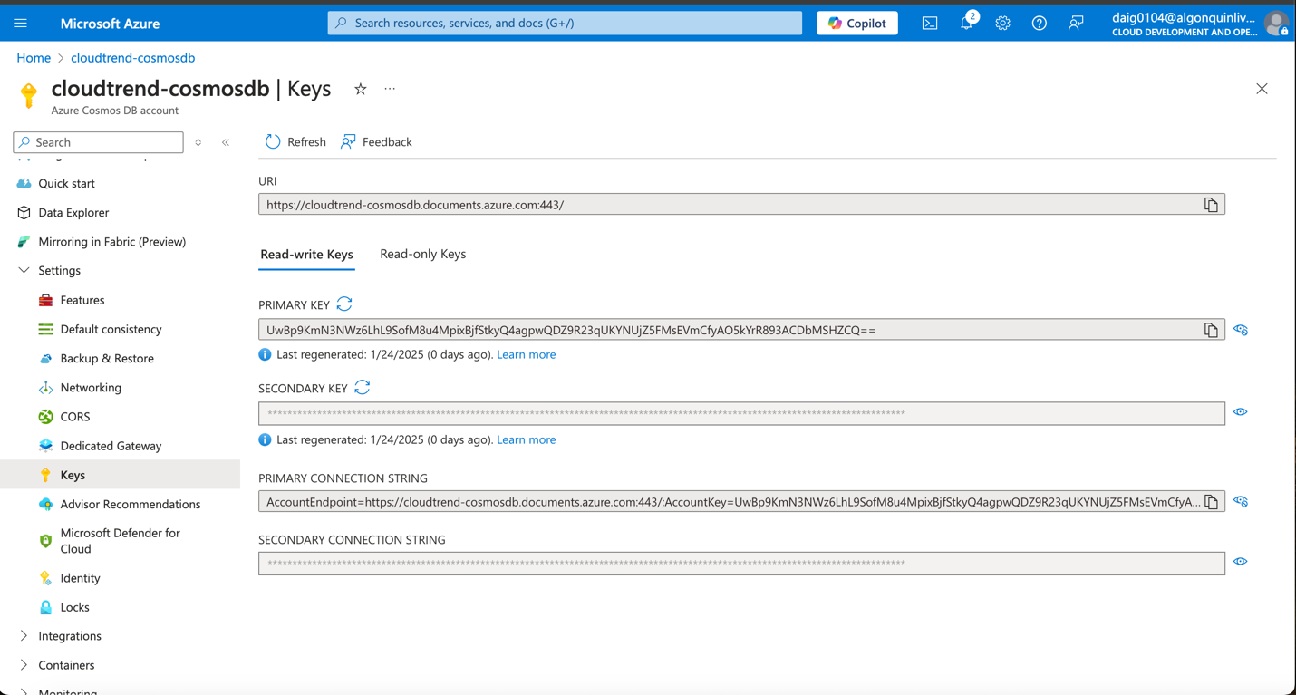

1. Creating a new products container as well as a new cosmicworks database:

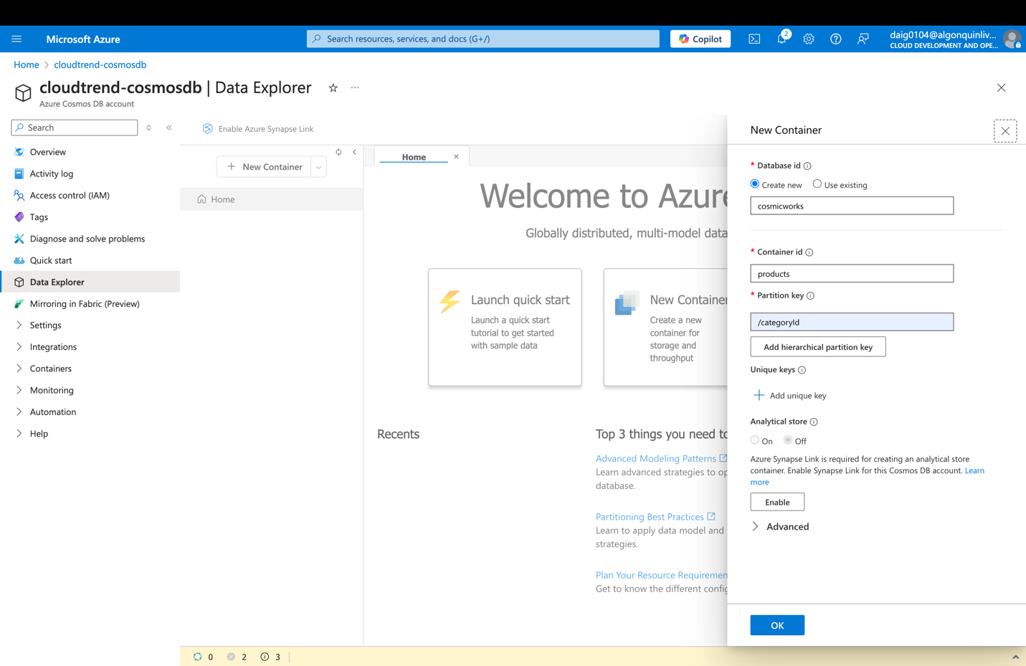

1. Creating another container, productslease connected to the cosmicworks database

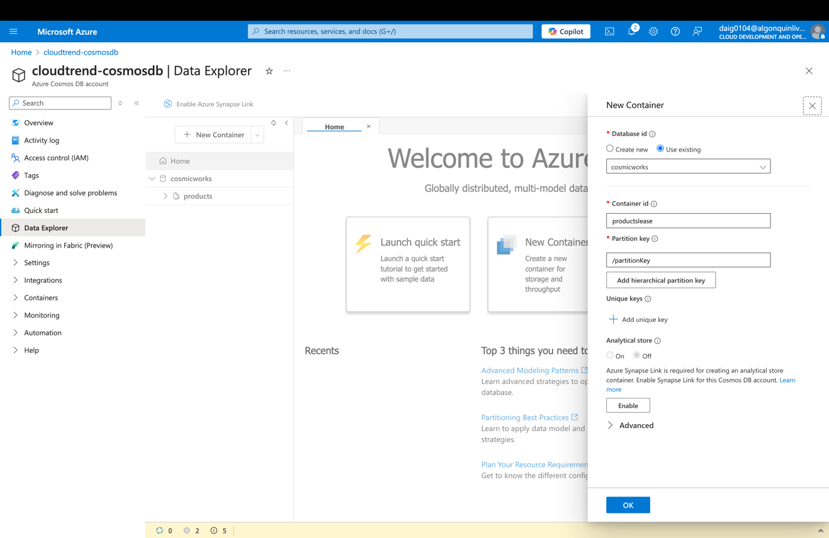

1. In VS code observing the product class and its properties string, name and id

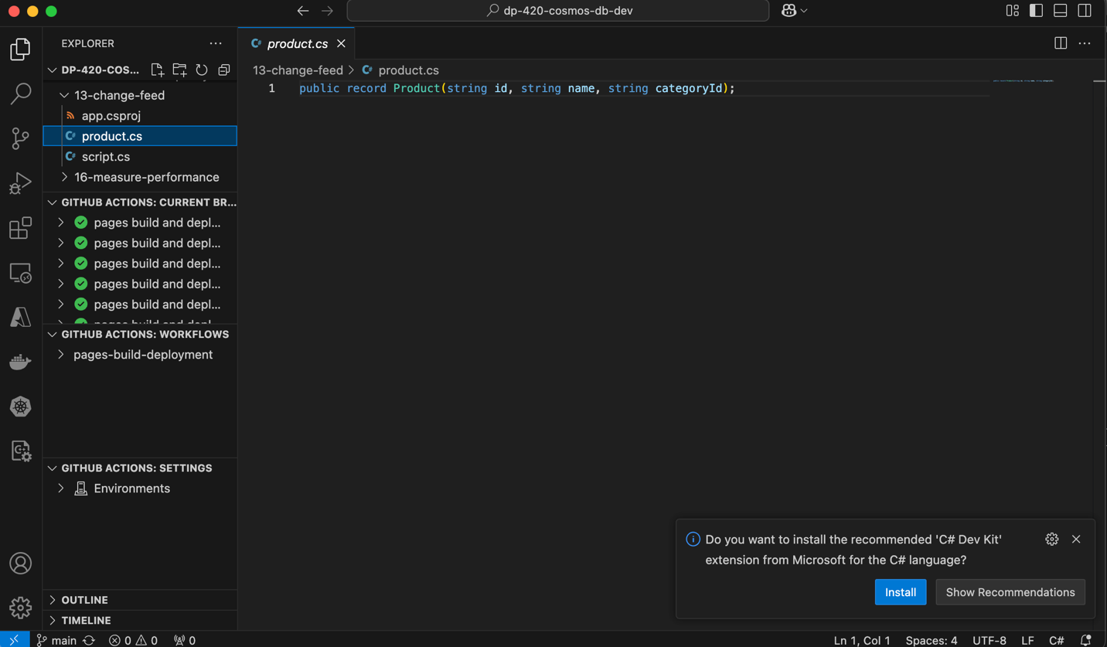

1. Back in the Explorer pane of Visual Studio Code, open the script.cs code file and adding the code in to retrieve and write containers.

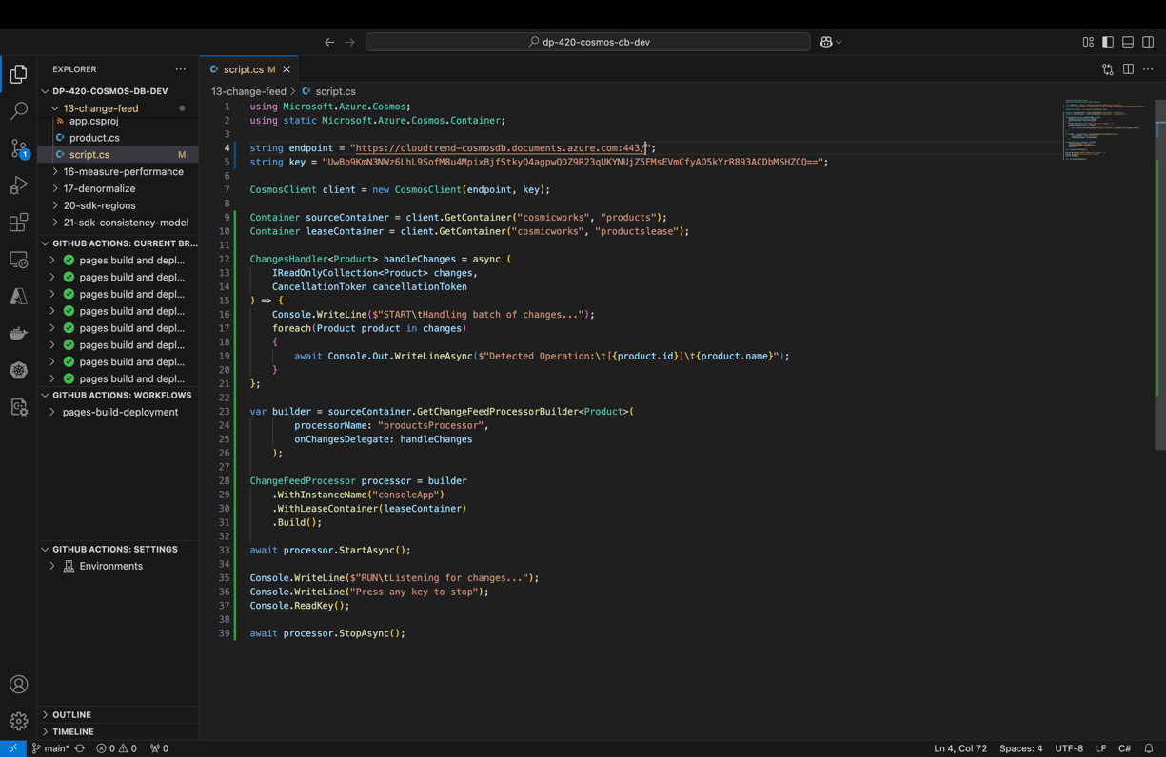

1. Build and run the project using the dotnet run command:

dotnet run. In addition to installing cosmicworks using dotnet tool install --global CosmicWorks --version 2.3.1 I had to add the environment export PATH="$PATH:/Users/cmdaigle/.dotnet/tools" to be able to use cosmic works on a mac

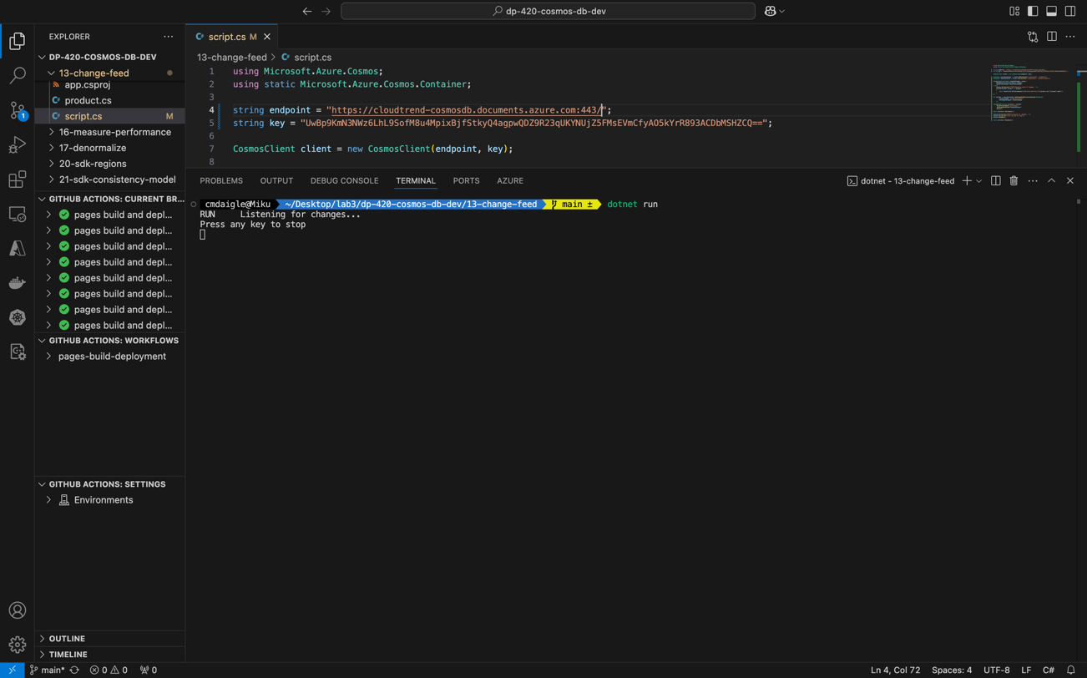

1. Run cosmicworks to seed your Azure Cosmos DB account with the following command-line options: Here is where I received the error. I tried various command options one of which:

cosmicworks --connection-string "<API_FOR_NOSQL_CONNECTION_STRING>"

Unfortunately, this is the main and first error I encountered. The error is: “Bad request, replacing offers is not supported for serverless”. Here, I start my research and troubleshooting errors

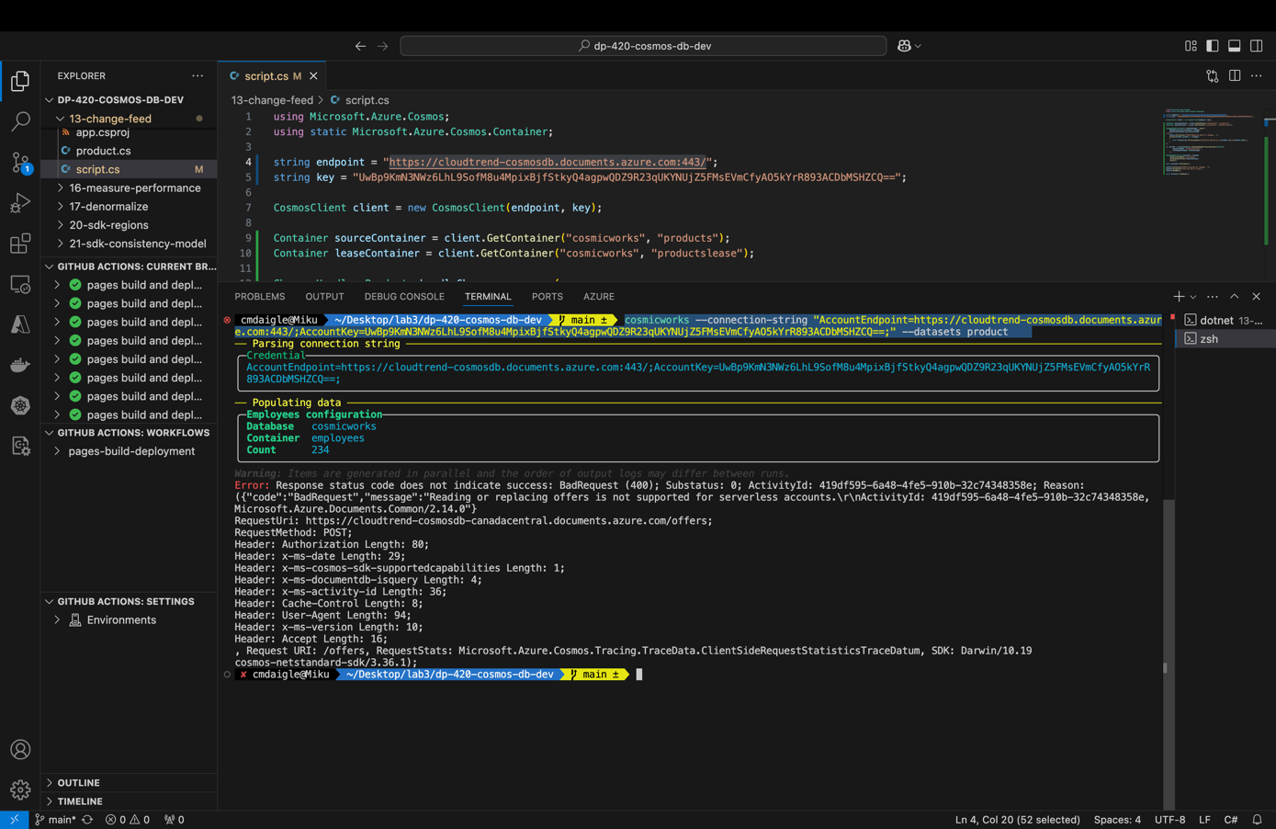

1. Here I read the documentation of cosmicworks (nuget, 2024) Which offers 3 different ways to seed the database continuing forward I experiment with the other options below:

**cosmicworks --endpoint <cosmos-endpoint> --key <cosmos-key> --datasets product**

This option requires the endpoint and database key. However, this option receives a different error: you can’t provide an endpoint without using role-based access control. This reveals the nature of the errors being subscription or azure-focused. In this case, the error suggests that I am being denied access to writing towards the database.

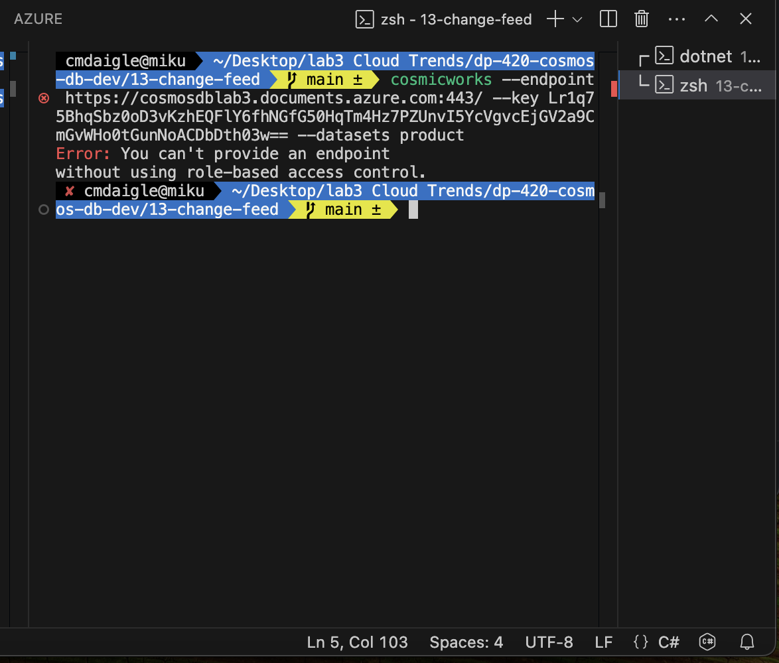

1. Here I try to add the –role-based-access-control to attempt to bypass the error in theory by invoking Microsoft Entra, or checking access of the account. Here, I get a more descriptive error “Unauthorized,” which further cements my theory that my Azure subscription may be denying write access to the database.

**cosmicworks --endpoint <cosmos-endpoint> --key <cosmos-key> --datasets product --role-based-access-control**

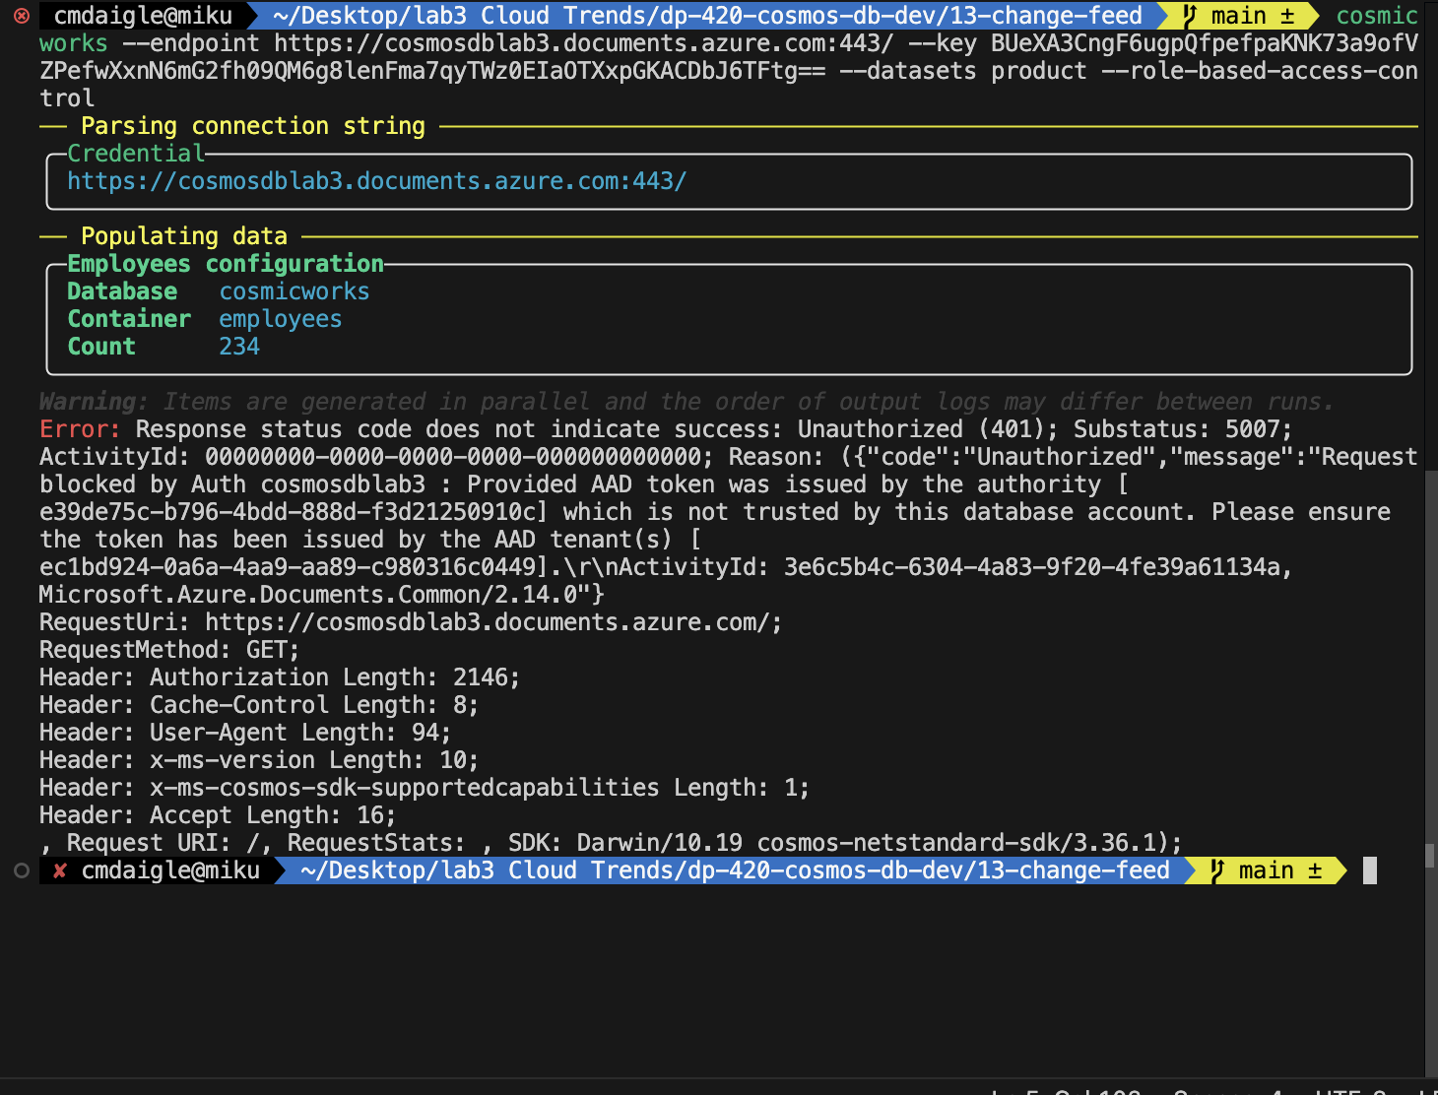

Here I try the third option, to see if that works unfortunately I get a similar access type error “forbidden”

**cosmicworks --endpoint <cosmos-endpoint> --role-based-access-control**

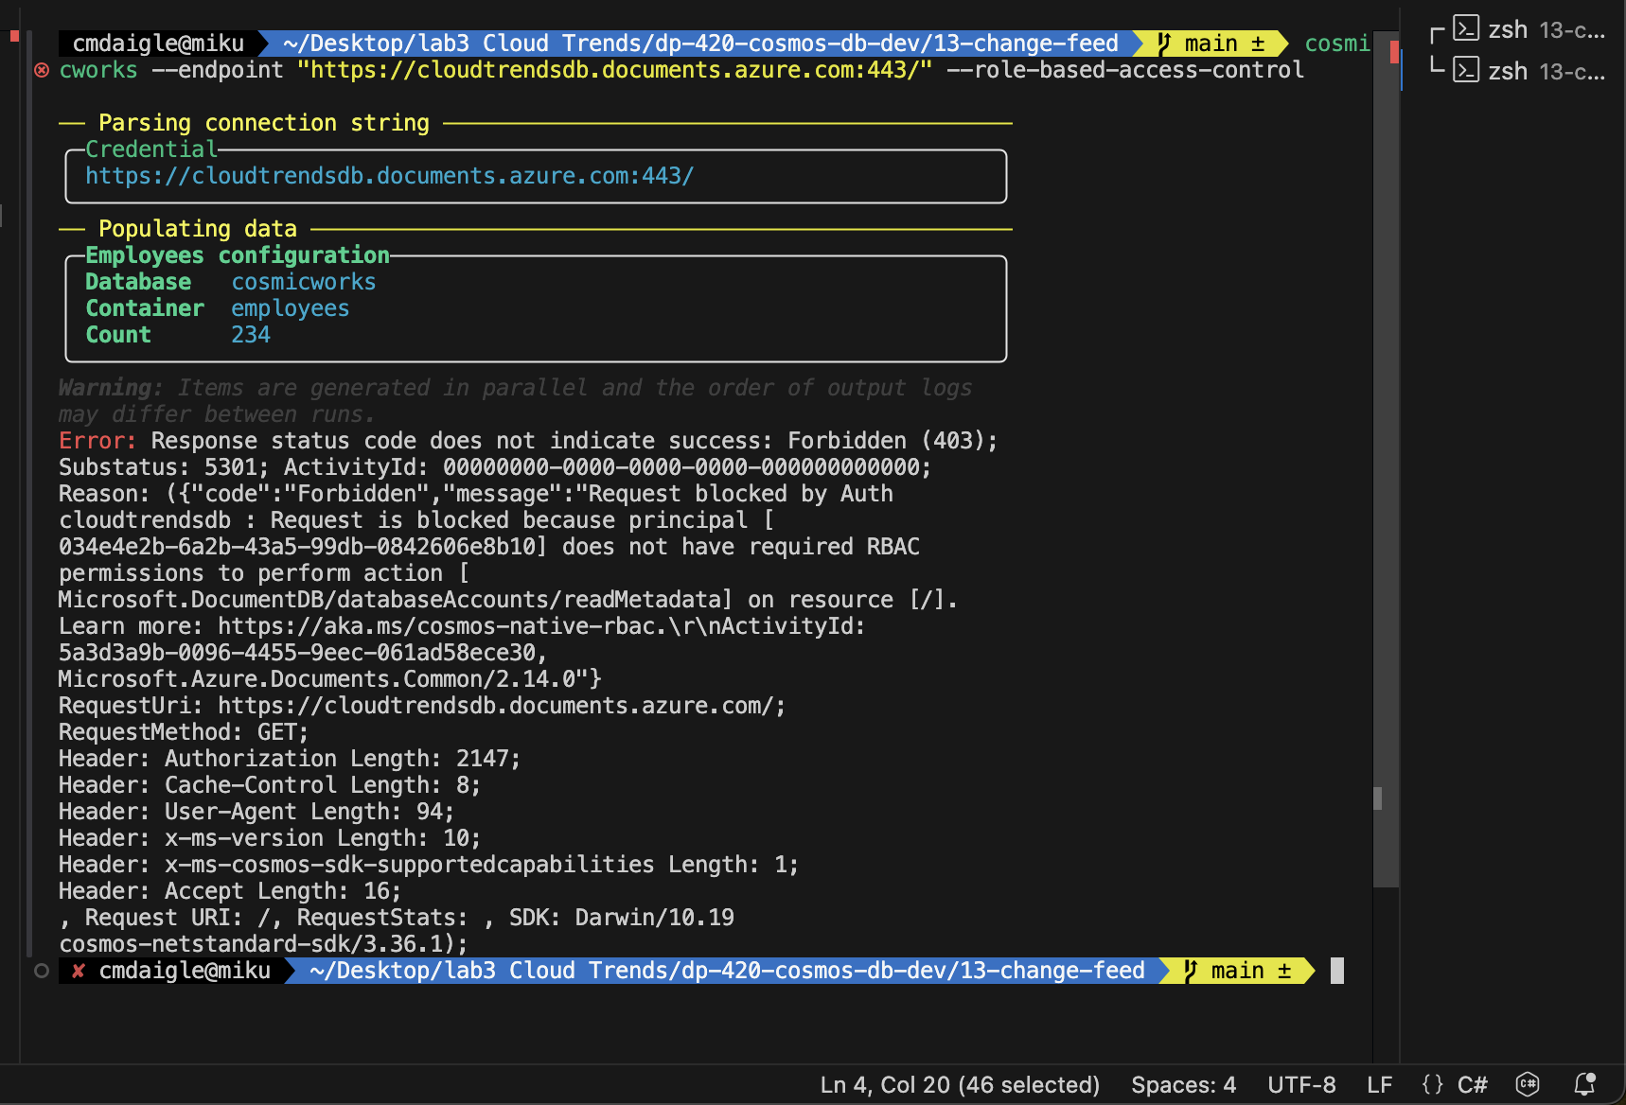

1. Here is me adding role assignments to the database Cosmos DB Operator and Cosmos DB Account Reader to attempt to solve the restriction error. (MoonHorse, 2024) Unfortunately adding these role definitions did not work and some of them are missing from the IAM role assignments page.

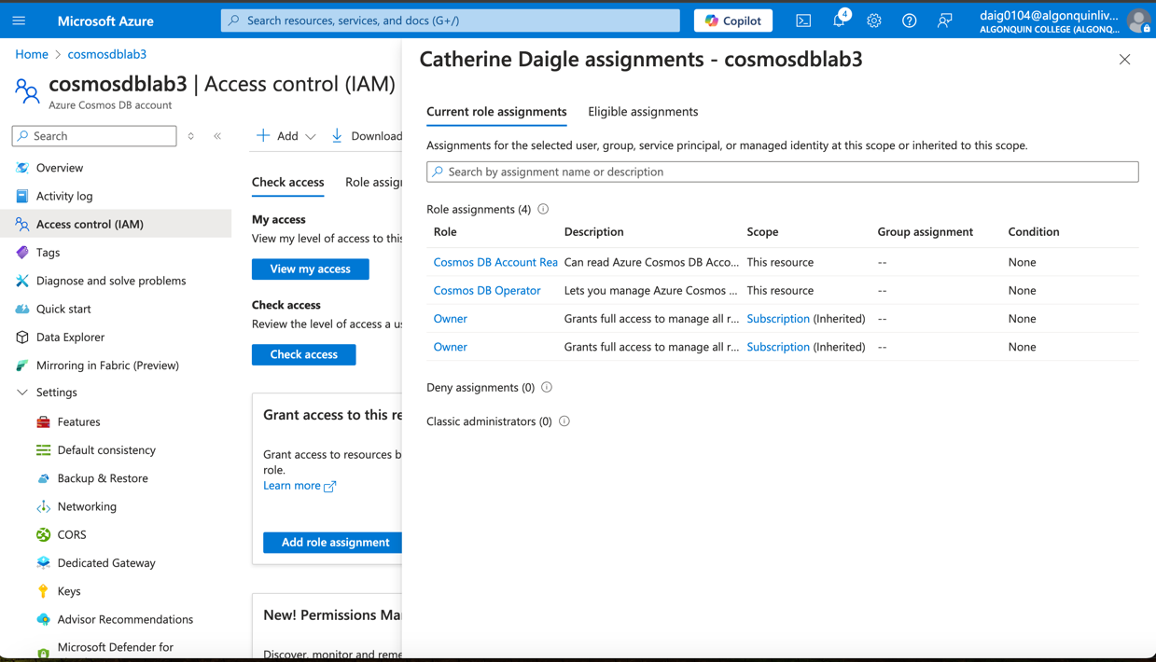

1. Other Solutions include using a Windows laptop rather than a Mac laptop but unfortunately, the same errors occur. Therefore, the errors have nothing to do with the operating system used.

## Create an Azure Function app and Azure Cosmos DB-triggered function

1. Create a function app in azure using the following configurations:

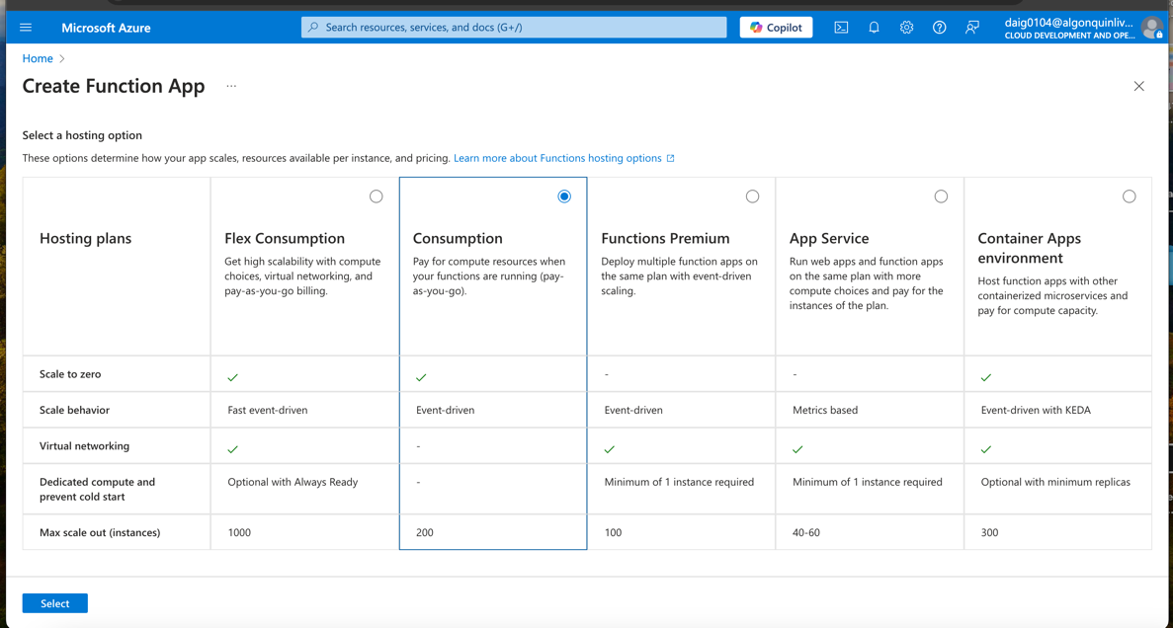

1. Creating the function app with windows .NET version 8 setting

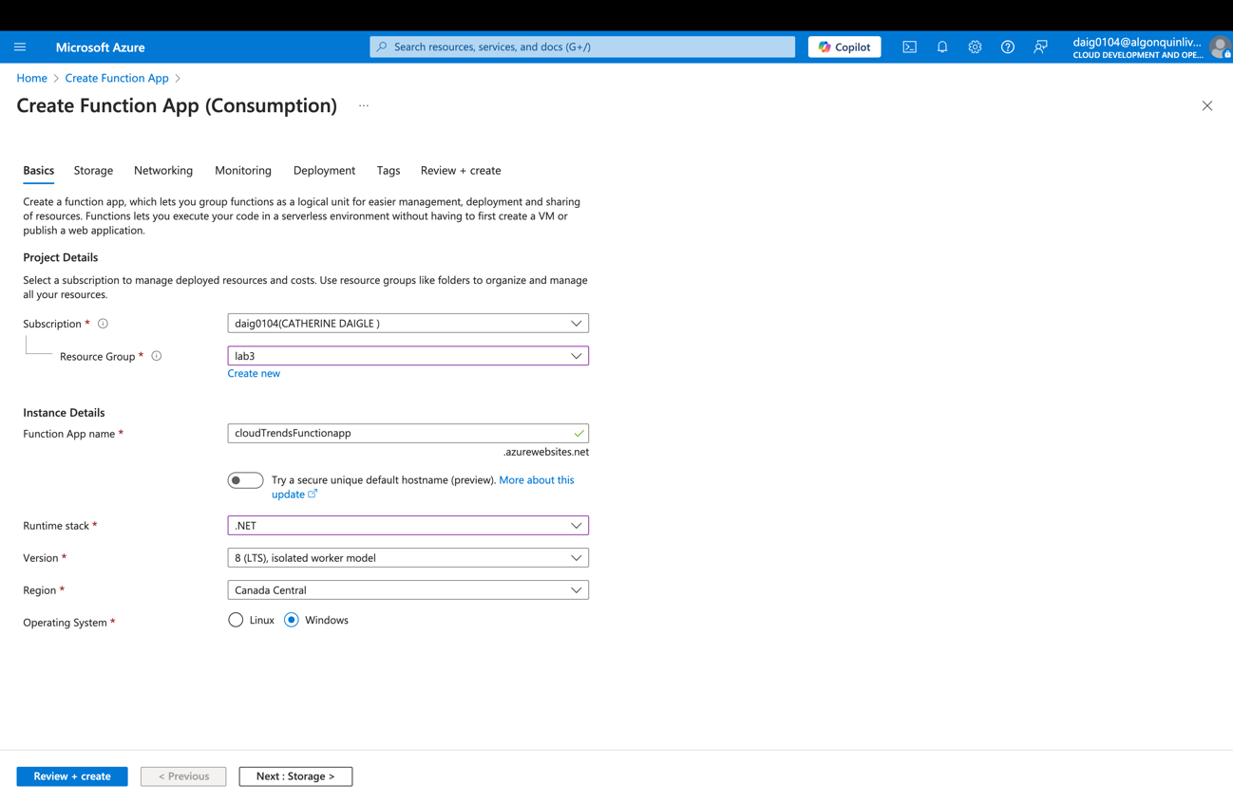

1. Function App review

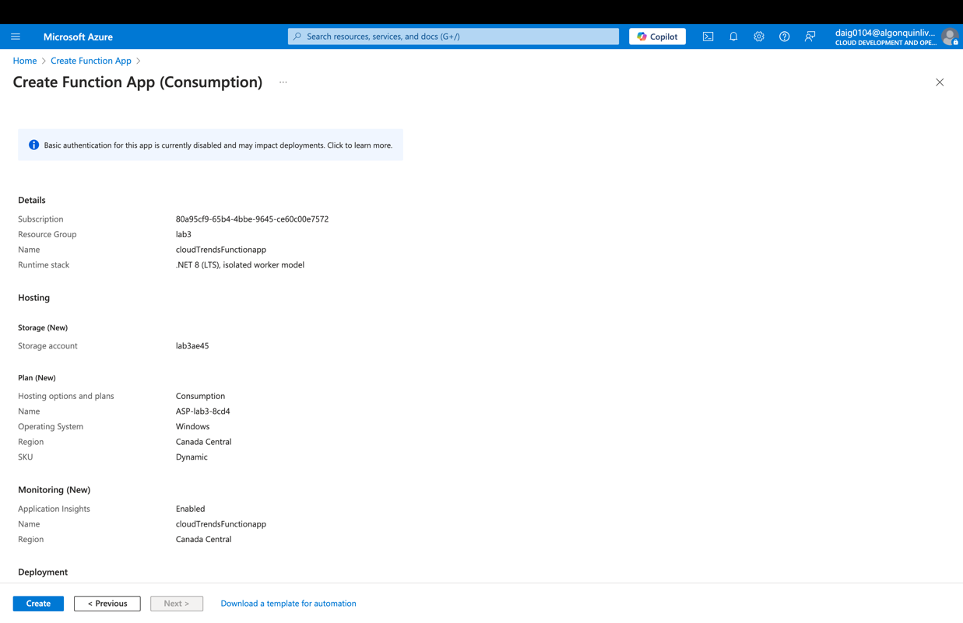

1. Creating a function with cosmosdb trigger. There is a small issue with the function app where “Create in Azure portal” To fix this, Go to Settings> Environment Variables and find “FUNCTION_WORKER_RUNTIME” and change “dotnet-isolated” to “dotnet”. (Raut, 2024)

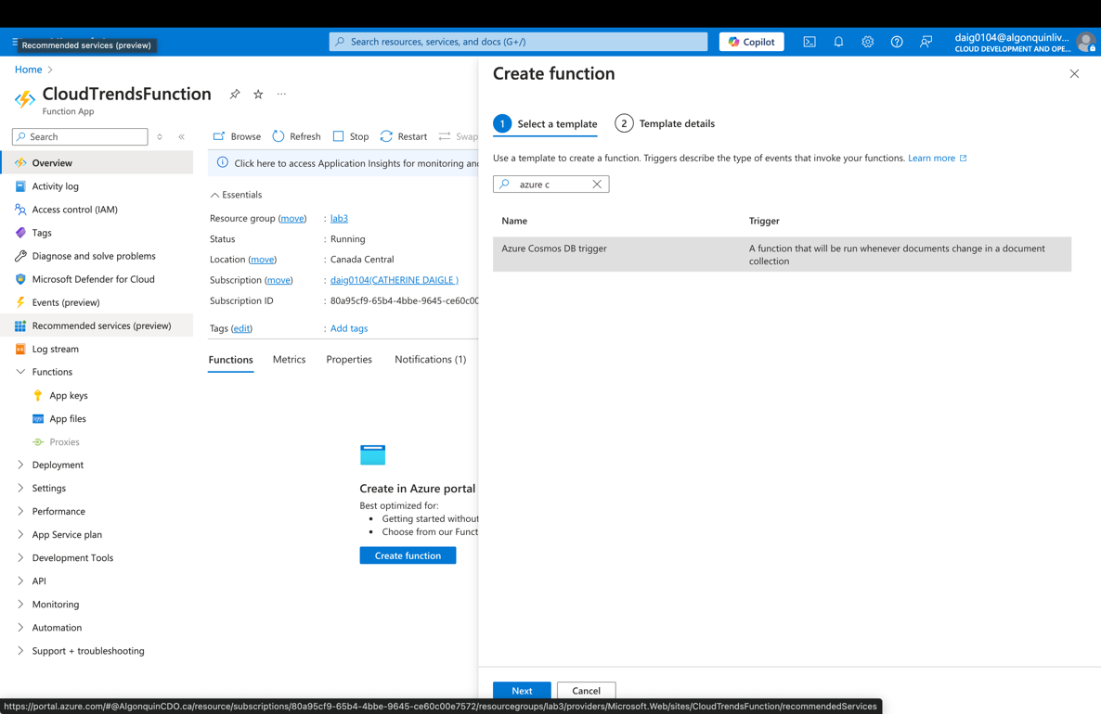

1. Configuring settings for the function app to connect to the database

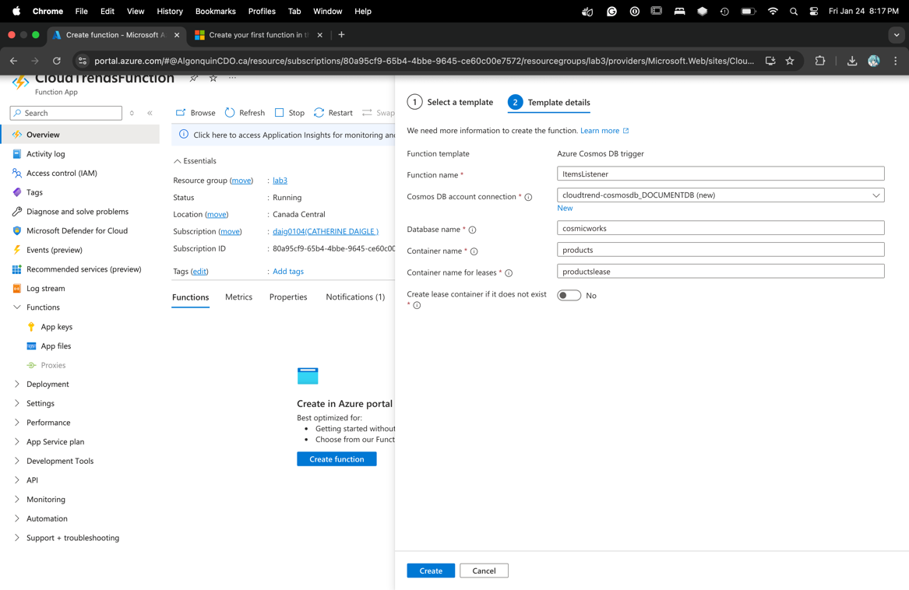

In the ItemsListener | Function pane, navigate to the Code + Test pane. Changing the function code to detect changes within the cosmos db. Below is its compiling, however without a seeded database, the compilation does not seem to be complete. I did have to change the code from #r "Microsoft.Azure.DocumentDB.Core" to #r "nuget: Microsoft.Azure.DocumentDB.Core" since it was giving me an error when trying to retrieve the dependency. (nuget, 2024)

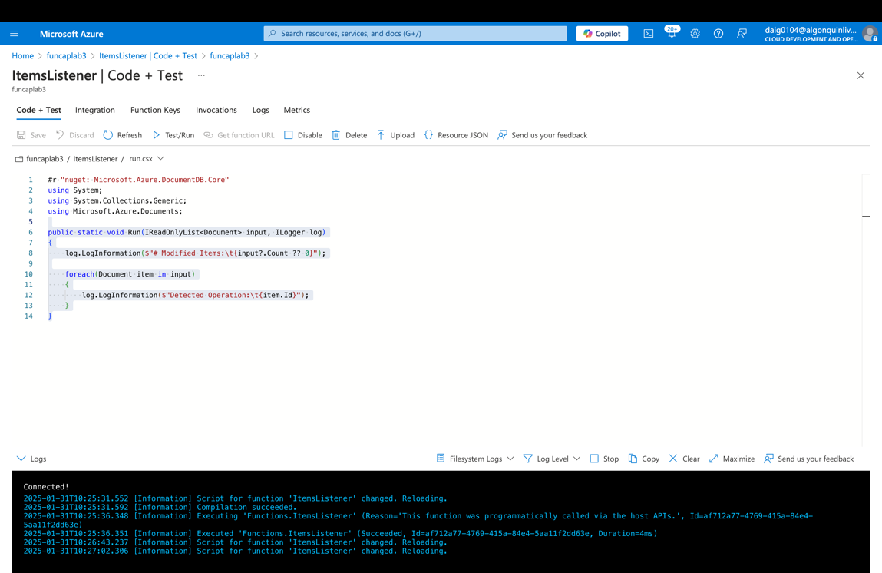

# Results:

The result was that I have not been able to complete the lab, although I have been able to create the database and the function app. Due to RBAC and account subscriptions, I encountered an error in which the subscription tier I was assigned does not allow me to write to the database. Therefore, I was able to complete the first half of the database part of the lab and the first half of the function part of the lab. (the latter part required the database to be seeded and I could not complete it)

# Conclusion:

My theory was that the database would be populated, however, and I would be able to get the function to notify me however, there were glaring errors within Azure that impeded my progress. I tried many different applications in an attempt to find a solution. I, unfortunately, could not find an answer above I explain my step-by-step process of troubleshooting each error. There is one attempt I did not attempt due to cost reasons, which is the error for “cosmicworks --connection-string "<API_FOR_NOSQL_CONNECTION_STRING>“ gave a “replacing offer is not supported for serverless” there is a chance switching the database to provisioned may solve this error, except a provisioned database has an increased cost compared to a serverless. Additionally, the error may appear deeper and switching database types may not necessarily work. The main cause of the error that I have surmised is due to subscription tiers and Access controls. Due to using an Azure subscription from Azure, access to write to the database is likely forbidden, hence giving the errors. This is further cemented by the “forbidden” errors output when using the other methods to seed the database in cosmicworks. Additional troubleshooting practices I have also attempted include switching the subscription type from CDO (Cloud development operations) subscription to the regular, Algonquin subscription. I was not able to seed the database in either of the subscriptions. I also used a Windows computer; however, I was quick to find out these errors are not OS involved.